TEAL User Instructions
These instructions will familiarize you with the TEA Login (TEAL) system.
TEAL is an updated, more secure replacement for TEA’s older web access management system, TEASE (TEA Secure Environment). TEAL enables you to request secure access to TEA applications and to manage your user account and profile information

Features of TEAL
TEAL provides access to TEA applications, which will help you to access student records, educator records, school financial data, and other information that must be kept secure from unauthorized access.

From the login page you can perform the following functions:
- Self-register for a TEAL account
- Request a forgotten password to be reset
- Request and automatically receive a forgotten username

From the main page you can do the following:
- Request access to TEA applications
- View the status of your requests
- Respond to requests submitted by other users, if you are an approver
- Mange your profile information
- Change your password
- Maintain and change security questions

Requesting a New User Account
- Open a web browser and go to https://pryor.tea.state.tx.us/.
- The TEA Login page appears.

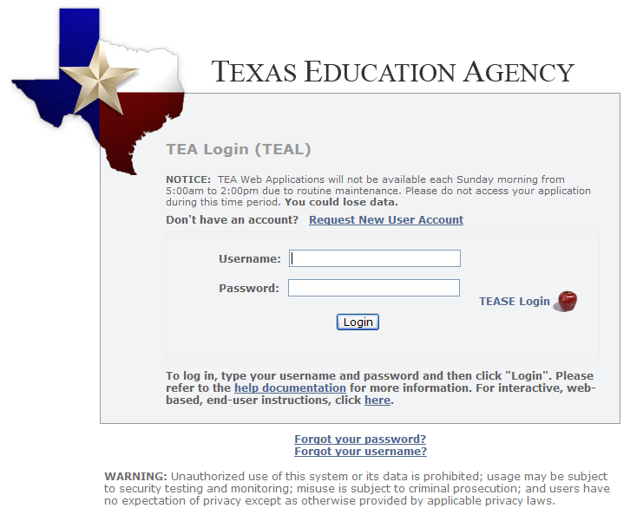

- Click the Request New User Account link.
- This is the new User Registration page. Required fields on this page are:
  - First Name
  - Last Name
  - Email Address
  - Verify Email
  - Birth Month
  - Birth Day, and
  - Organization Type

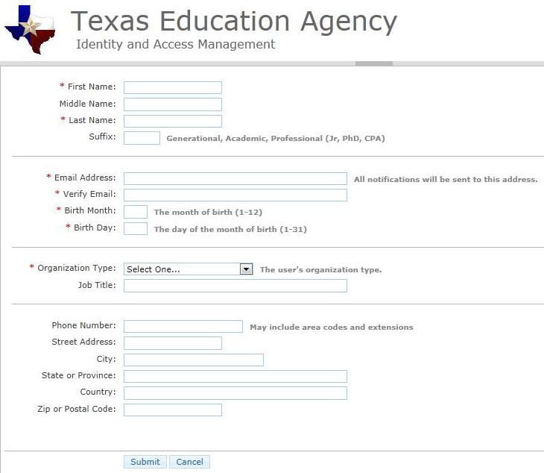

- Complete the form.
- Be sure your email information is correct. All notifications will be sent to this address including the information necessary to log in for the first time.
- Use the drop down list to select your organization type.
- If your organization type does not appear, select “None of the Above”. Depending upon your organization type, you may be asked to select your manager’s name and type your job title.
- When you have completed the form, click the Submit button. A message will appear acknowledging your request.
- You will receive an email with additional instructions.

Logging in and Out of TEAL
- Open a web browser and go to https://pryor.tea.state.tx.us/.
- The TEA Login page appears.

- Enter the username and password you received by e-mail.
- Click the Login button.
- When you log in for the first time, you will see this message: “Your password has expired. Please set a new password to continue.”
- Click in the Old Password text box to enter the password you received by e-mail.
- Type and retype the new password.
- Click the Submit button.
- When you log in for the first time, an assurance of security provisions appears. You must agree to these provisions to continue. The same provisions will appear at login every 30 days.
- Read the security provisions and click the I Agree button.
- If you do not agree to the security provisions, click Cancel to exit the application. However, you will be unable to access applications that use the TEAL system.
- After you agree to the security provisions, the security questions page appears. Here, you are prompted to select and supply answers to three security questions.
- TEAL uses these three questions to verify your identity if you forget your password. You must select the three security questions and provide answers. The answers to these questions are confidential, and nobody will review your request when you ask for a new password.

Be sure to note the exact answer, because the computer needs the exact response. For example, suppose you use the question In what city did you meet your spouse/significant other? and type the answer Ft. Davis, Texas. If, when you forget your password, you type the answer Fort Davis, Texas, or Ft. Davis, TX, the computer will not recognize that answer as correct.

- Click the Save Changes button
- A message appears that your challenge/response answers have been updated.
- The Applications page appears.

Getting a Password Reset and Username Reminder
- Open a web browser and go to https://pryor.tea.state.tx.us/.
- The TEA Login page appears.

Forgotten Password
- Click the Forgot your password? link.
- The TEAL password reset page appears, where you need to enter your Username.
- Click the Submit button.
- You will be asked to answer the three security questions you selected when registering.
Be sure to enter the exact answer you used when registering. For example, suppose you use the question In what city did you meet your spouse/significant other? and type the answer Ft. Davis, Texas. If, when you forget your password, you type the answer Fort Davis, Texas, or Ft. Davis, TX, the computer will not recognize that answer as correct.

- Click the Submit button. If you answered the questions correctly, the information is submitted to TEA and an automatic e-mail is generated containing a new password, which you must change as soon as you log in again.

Forgotten Username:
- Click the Forgot your username? link.
- The Forgot User Name page appears.
- Type your e-mail address. This address must be same as the one associated with your username; otherwise, the system will not be able to identify you.
- Click the Submit button.

If you do not receive an e-mail, contact TEA Computer Access at the e-mail address shown on the page.
A message appears that your username has been sent to your e-mail address.

Requesting Access to an Application
A TEAL username and password alone does not permit access to TEA applications. You will need to submit an application access request and receive approval in TEAL to access each application. After you have logged in you will see a Self-Service section in the upper left column. This section gives you quick access to all of the profile and application information you will need to use TEAL.
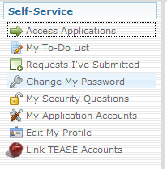
- To request access to an application, click the My Application Accounts link. The My Accounts page appears, where you can apply for access to a TEA application or view the applications you already have access to.
- Click the Request New Account button.
- A pop up window appears with the list of accounts. Highlight the account you are interested in and click Go To Account Details form.
- The My Accounts page of the selected application appears. This page may be different for each application and is only an example.

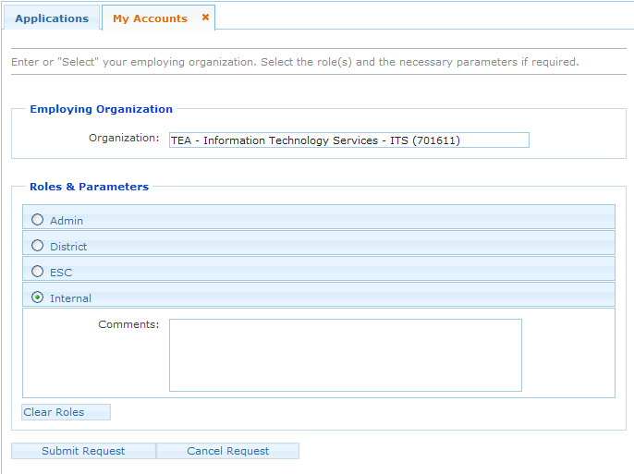
- Click in the Organization field to enter your organization.
- Select your organization name and id.
- Select the radio button for your role. The roles in this example are Admin, District, ESC, Internal.
- Type in any additional details related to the request in the comments section, if required.
- Click the Submit Request button.
- A success message appears that the request was submitted successfully.
Note: You can submit multiple requests at the same time, as long as access to a different application or organization is requested each time.

Accessing an Application
- Applications you have been granted access to appear as links in TEAL. After you have requested and been granted access to a TEA application, you can easily access that application through TEAL by clicking the Access Applications link in the Self-Service section.
- The application opens up in a new web page. If you have access to multiple applications, each application will be listed separately.

Linking TEASE Accounts
You may have some applications secured by TEAL while others are secured by TEASE. You can link TEAL and TEASE.
- Under the Self-Service section, click the Link TEASE Accounts link.
- The Link TEASE Account page appears.
- Click the Link a TEASE account button.
- Click in the TEASE User ID field to enter your TEASE user username.
- Click in the TEASE Password field to enter your TEASE password.
- Click in the Confirm Password field to retype the password.
- Click the Submit button.
- A message appears that the request was successfully submitted.
- Click the Refresh account list button.
Your TEASE account is now linked to the TEAL system. You can now access the TEASE applications from TEAL. Note: You can no longer use this TEASE username to directly log in to TEASE.

Other Self-Service Features and Help
You can use the Self-Service features to manage and edit many features of your profile. Check out the links in the Self-Service section and follow the instructions. Use thebutton in the upper right hand of the page for more information.

