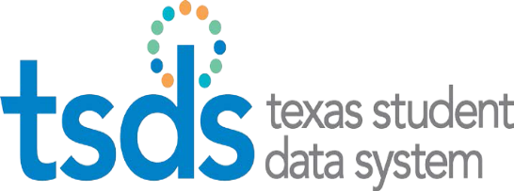

**TSDS Vendor Training**

**August 1, 2019**

**Presented by the Texas Education Agency**

**Information Technology Services Business Management Division**

*William B. Travis Building, Room 1-104*

*1701 N. Congress Ave.*

*Austin, TX 78701*

**Meeting Agenda – August 1, 2019**

|  |  |  |
| --- | --- | --- |
| 8:00 a.m. | **Registration** |  |
| 8:30 a.m. | **Welcome, Legislative Update and Introductions** | Terri Hanson |
| 9:00 a.m. | **TSDS Update**   * Unique ID * Early Childhood Data System (ECDS) * PEIMS   **New TSDS Collections & Projects**   * Class Roster   **2019-2020 Release Schedule** | John Reese  Ed Linden  Candice DeSantis  Kathy Adaky  Candice DeSantis |
| **Residential Facility (RF) Tracker** | Kathy Adaky |
| **SPPI-14** | Nicole Schuessler |
| 10:00 a.m. | BREAK |  |
| 10:15 | **HB 3 Updates- Part 1**  Student Census Block Group  Prekindergarten Programs Eligibility and Funding  Prekindergarten Minutes and Instructional Programs  Residential Facility Attendance Reporting  Dyslexia and Related Disorder Services Reporting | Terri Hanson |
| 11:00 | **HB 3 Updates – Part 2**  Gifted and Talented Program Code  Expanded Learning Opportunities – Campus Only Reporting  Leaver Reason Codes – Early Notice | Michele Elledge |
| **HB 3 - New Tech Indicator & Expansion of Career & Technical Education** |
| 11:30 a.m. | LUNCH |  |
| 1:00 p.m. | **HB 3 - Bilingual Services Reporting** | Michele Elledge |
| 1:45 | **Discipline Reporting** |
| 2:00 p.m. | BREAK |  |
| 2:15 | **Other Legislative Items with Data Collection/TEDS Impact**  HB 1051 and HB 1746 – AT-RISK-INDICATOR-CODE definition  HB 165 – Endorsements for students receiving special education services  SB 1557 – Military Connected Students  HB 2190 – Students of Charter School Employees | Leanne Simons |
| 2:30 p.m. | **Data Collection Changes**  Armed Services Vocational Aptitude Battery (ASVAB) Revisions  Dyslexia Risk Reporting / DYSLEXIA-RISK-CODE (C222)  SERVICE-ID (C022) | Leanne Simons |
| 2:45 | **Code Table Changes**  INDUSTRY-CERTIFICATION-LICENSURE-CODE (C214)  PROGRAM-OF-STUDY-CODE (C220)  Dual Credit Reporting / COURSE-SEQUENCE-CODE (C135)  Campus Enrollment Type Reporting / CAMPUS-ENROLLMENT-TYPE-CODE (C219) | Michele Elledge |
| **TREx Updates** |
| 3:00 p.m. | **Business Rule Updates** | Michele Elledge |
| 3:30 | **Technical Data Collection Changes** | Candice DeSantis |
| 4:00 | **TSDS Roadmap** | Terri Hanson |
| 4:30 | **TWEDS Update** | Leanne Simons |
| 5:00 p.m. | Session Ends |  |