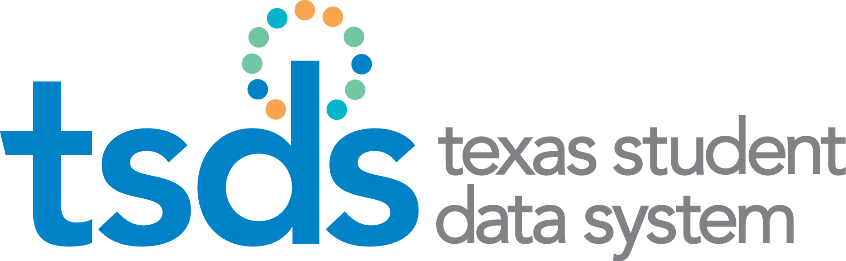

Texas Education Data Standards (TEDS)

2021-2022 Cumulative Change Log – Code Tables

Preliminary Version 2022.0.0
December 1, 2020

Prepared by: Information Technology Services Business Management Division

Table of Contents
TSDS Code Table Changes 3
C147 – PROGRAM-INTENT-CODE 3
C161 – STUDENT-ATTRIBUTION-CODE 3
C178 – CRISIS-CODE 4

Action column:
New = this indicates that the code table and code(s) are new to TEDS
Added = this indicates that the code is new to the code table which already exists in TEDS
Revised = this indicates that the code has been updated in TEDS
Deleted = this indicates that the code table/code has been deleted from TEDS

TSDS Code Table Changes

C147 – PROGRAM-INTENT-CODE
Data Element Id |  | Data Element Name |  | XML Name | Complex Type |  | ODS Coll | Data Coll | Submission
E0320 |  | PROGRAM-INTENT-CODE |  | TX-ProgramIntentCode | ActualExtension |  | MDYR(2) | PEIMS | Mid-Year
Version | Code |  | Value Before |  |  | Value After |  |  | Action
2022.0.0 | 43 |  | Dyslexia – Special Education  Actual Eligible: |  |  | Dyslexia – Special Education  Actual Eligible: Y |  |  | Revised

C161 – STUDENT-ATTRIBUTION-CODE
Data Element Id |  | Data Element Name |  | XML Name | Complex Type |  | ODS Coll | Data Coll | Submission
E1000 |  | STUDENT-ATTRIBUTION-CODE |  | TX-Attribution | StudentSchoolAssociationExtension |  | FALL(1)  SUMR(3)  EXYR(4) | PEIMS | Fall  Summer  Ext Year
Version | Code |  | Value Before |  |  | Value After |  |  | Action
2022.0.0 | 31 |  | Open Enrollment Charter School: Outside Attendance/Geographic Boundaries |  |  |  |  |  | Deleted

C178 – CRISIS-CODE
Data Element Id |  | Data Element Name |  | XML Name | Complex Type |  | ODS Coll | Data Coll | Submission
E1054 |  | CRISIS-CODE |  | TX-CrisisIndicator | StudentExtension |  | FALL(1)  SUMR(3)  EXYR(4) | PEIMS | Fall  Summer  Ext Year
Version | Code |  | Value Before |  |  | Value After |  |  | Action
2022.0.0 | 8A |  | COVID19: On September 28, 2020 student is being instructed on-campus |  |  |  |  |  | Deleted
2022.0.0 | 8B |  | COVID19: On September 28, 2020 student is being instructed through the remote synchronous method. |  |  |  |  |  | Deleted
2022.0.0 | 8C |  | COVID19: On September 28, 2020 student is being instructed through the remote asynchronous method. |  |  |  |  |  | Deleted
2022.0.0 | 9A |  | COVID19: On October 30, 2020 student is being instructed on-campus. |  |  |  |  |  | Deleted
2022.0.0 | 9B |  | COVID19: On October 30, 2020 student is being instructed through the remote synchronous method. |  |  |  |  |  | Deleted
2022.0.0 | 9C |  | COVID19: On October 30, 2020 student is being instructed through the remote asynchronous method. |  |  |  |  |  | Deleted

