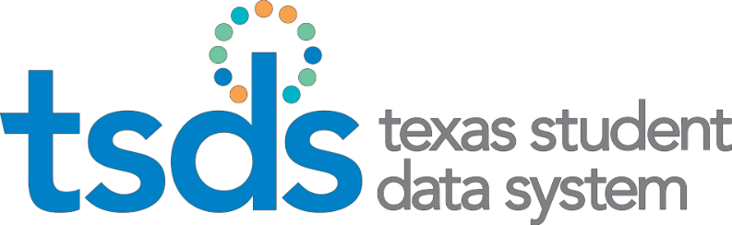

SPPI-14

State Performance Plan Indicator (SPPI) 14 Collection
TSDS ready to load data to eDM | August 7, 2023
SPPI-14 ready for users to promote data | September 11, 2023
SPPI-14 ready for users to complete | October 30, 2023
SPPI-14 Submission due date for LEAs | February 15, 2024
SPPI-14 data available to customers | February 29, 2024

Application Updates for 2023-2024
None

Business Rule Updates
New Business Rule for 2023-2024
Rule # | Rule Text / Business Meaning | Error Level
49010-0011 | If CONTACT-PRIORITY is not blank, then it must not match CONTACT-PRIORITY for any other parents associated with this student. | F
49010-0011 | ContactPriority must be unique for each parent associated with a particular student. | F

Frequently Asked Questions
Q: Does data element HOME-LANGUAGE-CODE (E0895) need to be reported for all SPPI-14 students? Why is it marked as optional in the StudentExtension complex type?

A: Yes, fatal validation rule 40203-0023 will fire in the SPPI-14 collection for any student not reported with the HOME-LANGUAGE-CODE (E0895) data element. The data element is marked as optional in the StudentExtension complex type, as it is not required for other TSDS Core collections.

Q: Which primary disability and instructional setting codes are promoted to SPPI-14?
A: The primary disability and instructional setting codes that are promoted for the SPPI-14 collection are those that are associated with the latest EFFECTIVE-DATE (E1632) for the student from the prior year PEIMS Summer (or Fall) Submission.

Known Issues
None

